**Project Proposal: MacroMastery**

1. What goal will your website be designed to achieve?

Diagnose the units and/or subunits that an AP Macro student should review to achieve the best possible exam score or to identify areas of content that have not yet been mastered.

Provide a substantial number of practice multiple-choice questions based on the diagnosis and, optionally, on the user's available time.

Aids students in time management by providing information on the time spent on each question.

Visually display the student’s progress in terms of practiced questions, content mastery, and, when possible, the extent of improvement since starting to use the application.

2. What kind of users will visit your site? In other words, what is the demographic of your users?

Targeted: AP Macro students worldwide (15-21 years old).

Not targeted: Economics teachers, Macroeconomics students and people interested in Economics.

3. What data do you plan on using? You may have not picked your actual API yet, which is fine, just outline what kind of data you would like it to contain.

The database will contain Practice Questions, User Profile, Diagnostic Data, Practice Data and Progress Tracking.

4. In brief, outline your approach to creating your project (knowing that you may not know everything in advance and that these details might change later). Answer questions like the ones below, but feel free to add more information:

a. What does your database schema look like?

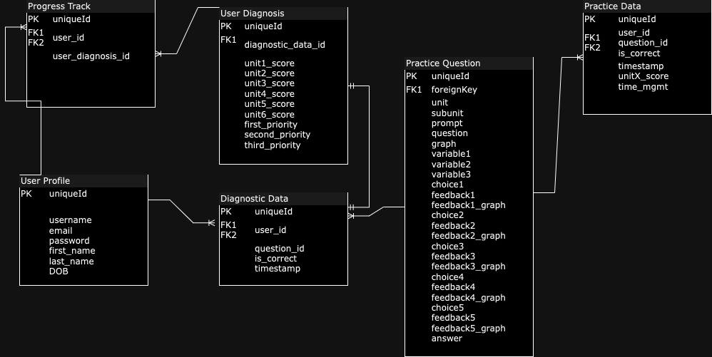

b. What kinds of issues might you run into with your API?

Since I’ll be building the database, I don’t foresee having much trouble with the API, since it’ll be straight CRUD. I do envision running in some trouble with the database, especially with the questions table. This is because I want to have a large amount of questions and I don’t have a clear vision of how to achieve this right now (if it’s through logic or through the database).

c. Is there any sensitive information you need to secure?

User email, password, first_name and last_name.

d. What functionality will your app include?

Create a user, run a diagnosis test and keep track of progress, run unit tests (with the ability of choosing either the amount of questions/time) and keep track of scores, show clock and, if possible, show a calculator.

e. What will the user flow look like?

Sign up -> Diagnose test -> Practice tests -> Diagnose test -> Practice test and s on

f. What features make your site more than CRUD? Do you have any stretch goals?

The algorithm that will communicate which units to study, as well as mastery in a unit. A nice feature of this site could be the way that the questions are formulated: if I’m able to come up with a way to produce questions dynamically, the question bank could be large without occupying much space. The fact that progress is being compared with where the user was.

Stretch goals: Users can set personal goals.

Users can give feedback on particular questions.

Add achievements and badges for users.

Payment and Subscription functionalities.